## GITHUB:

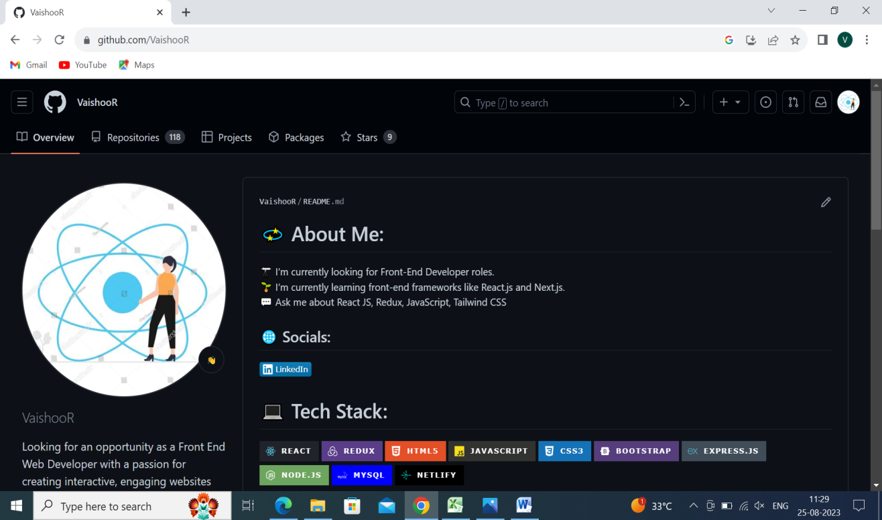

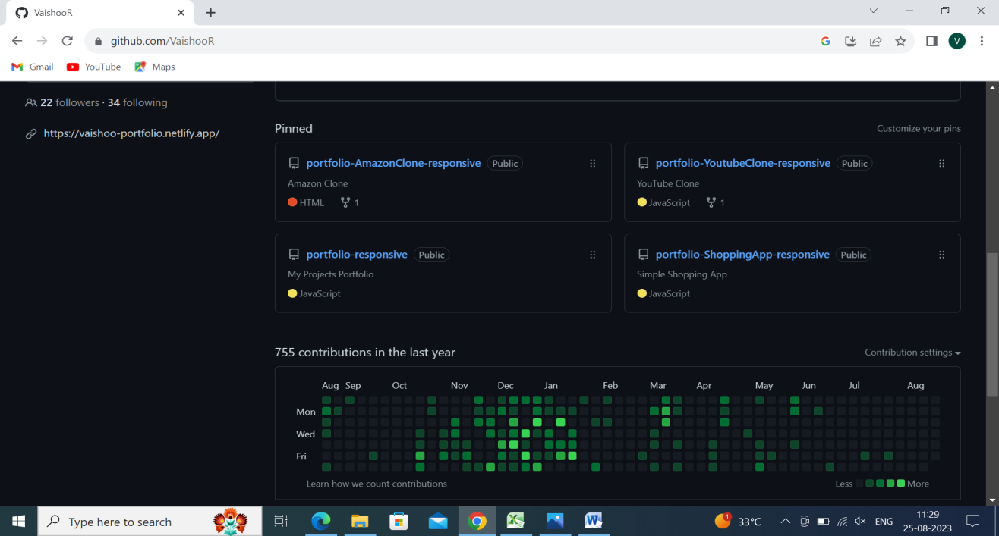

1SELECTORS:

Universal & Tag selector:

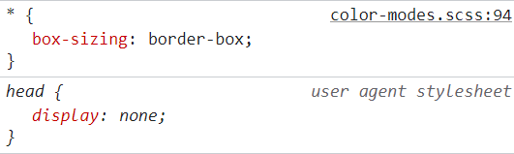

Class selector:

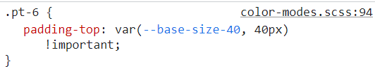

Attribute selector:

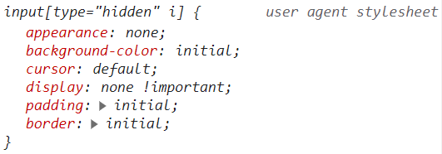

PROPERTIES & VALUES:

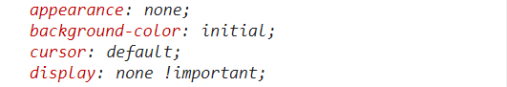

DECLARATION BLOCKS:

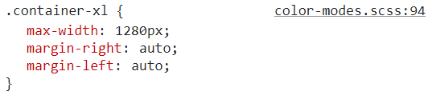

INHERITANCE:

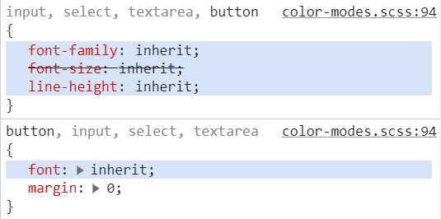

COLORS:

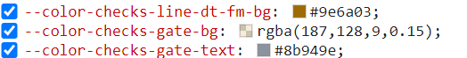

BOX MODEL:

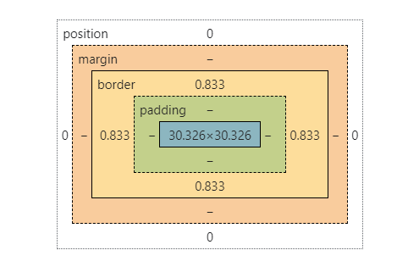

FONTS:

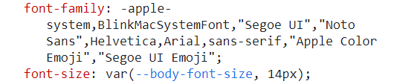

UNITS OF MEASUREMENT:

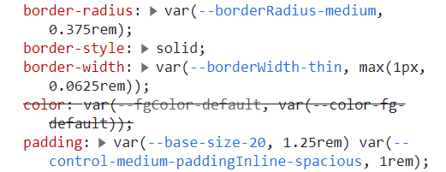

rem

pixels

INLINE, INTERNAL & EXTERNAL CSS:

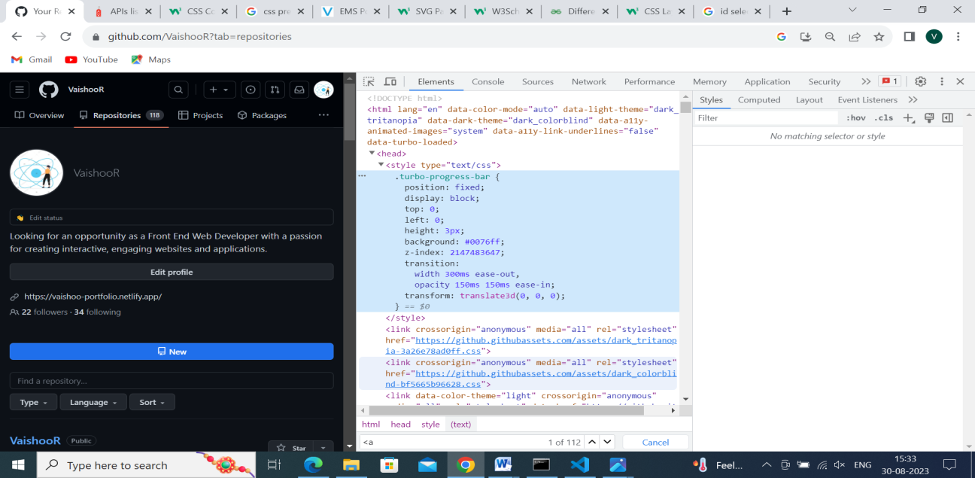 INTERNAL

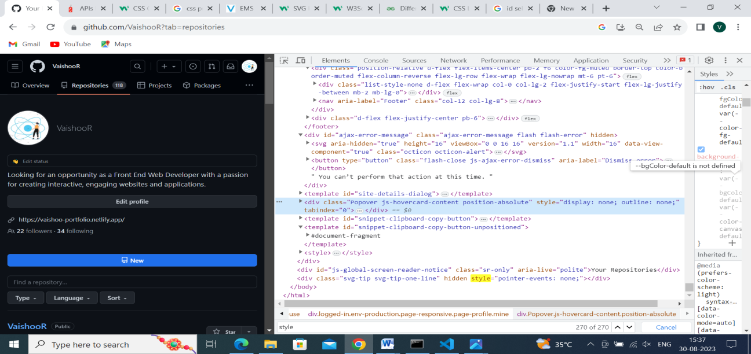 INLINE

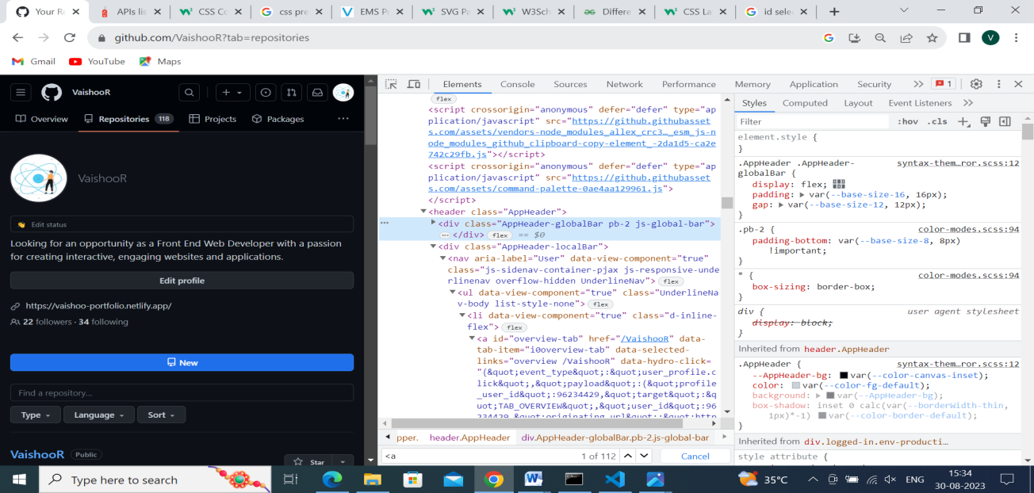 EXTERNAL

RESPONSIVE DESIGN:

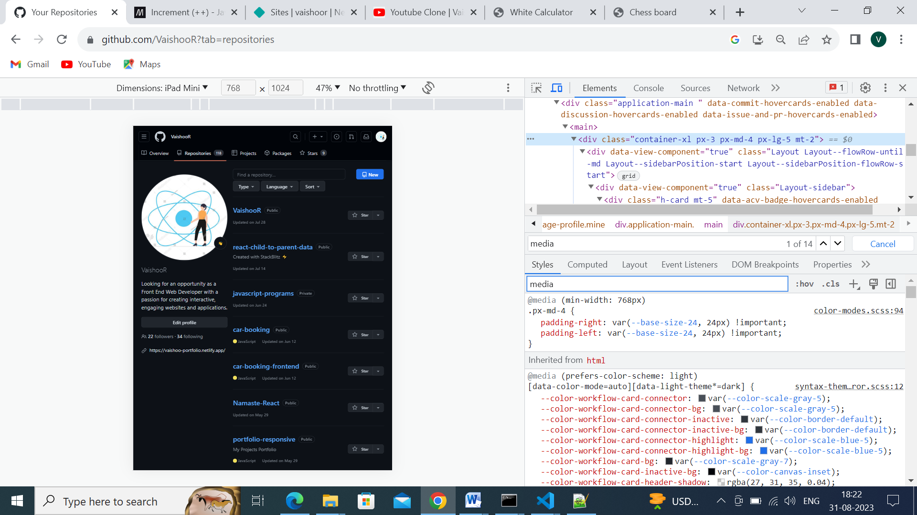

TRANSITIONS & ANIMATIONS:

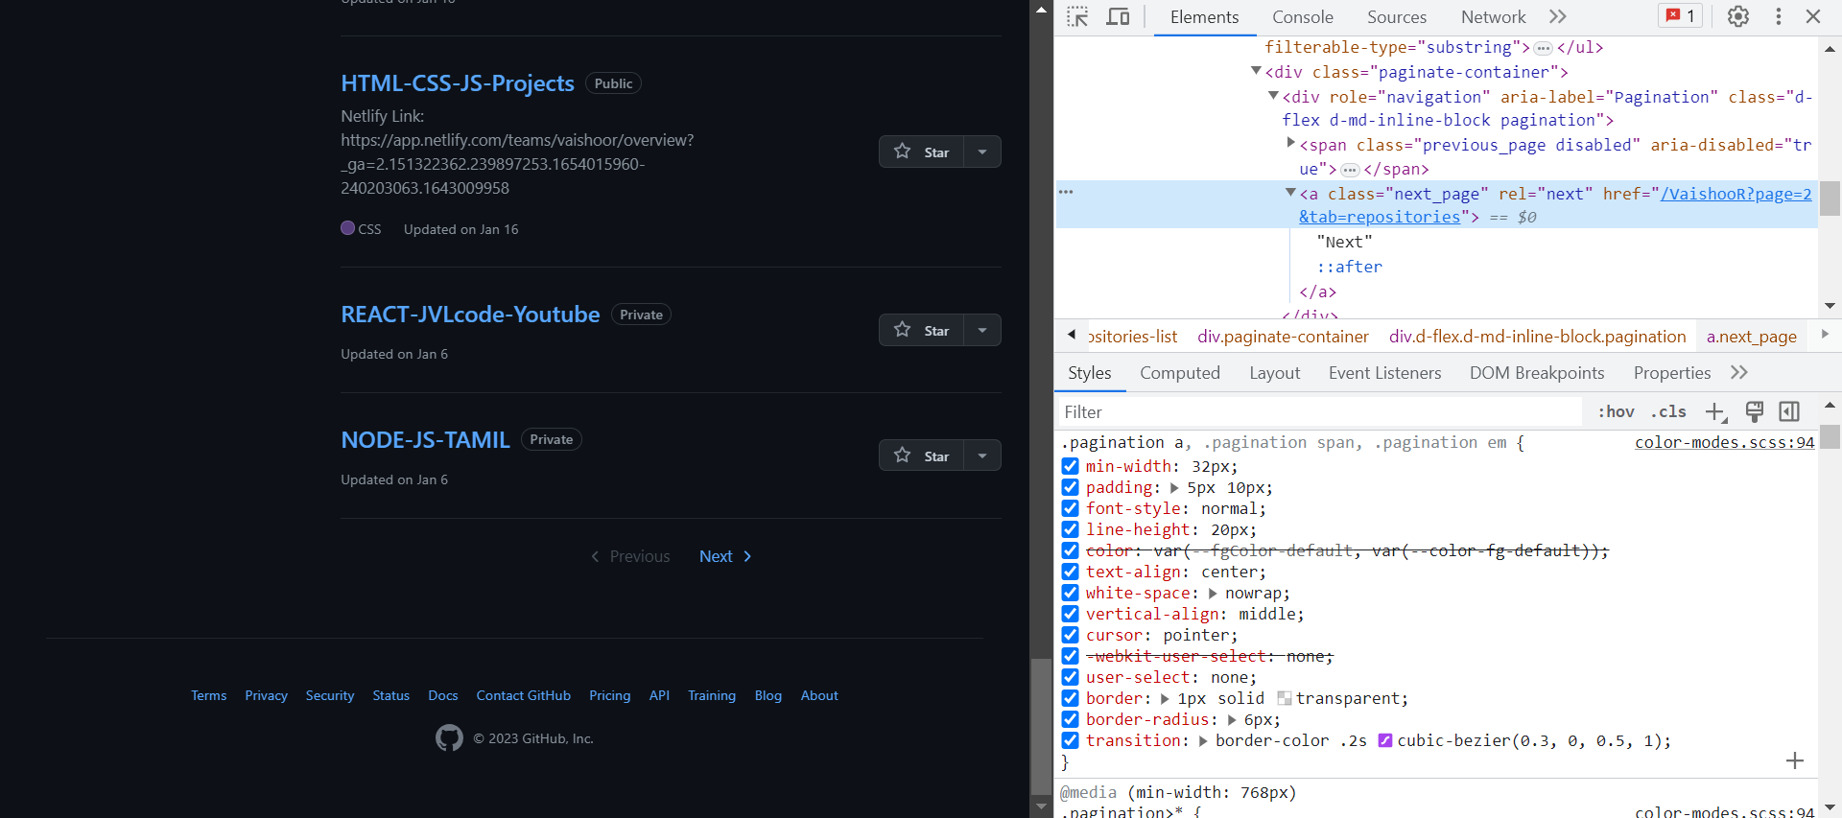

PSEUDO-ELEMENTS & PSEUDO-CLASSES:

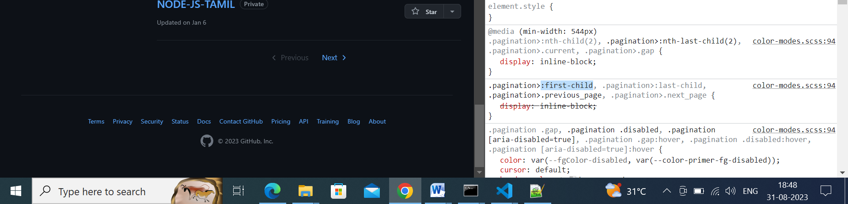

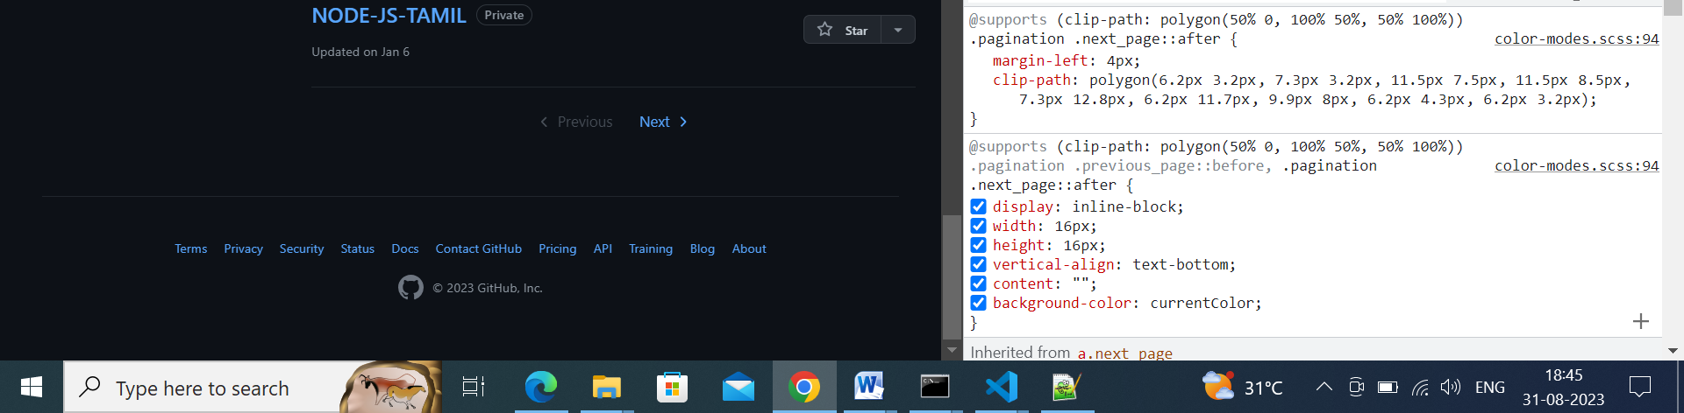

VENDOR PREFIX:

